Open power Bi 🡺

Import data from Excel

Choose the Excel File(titles)

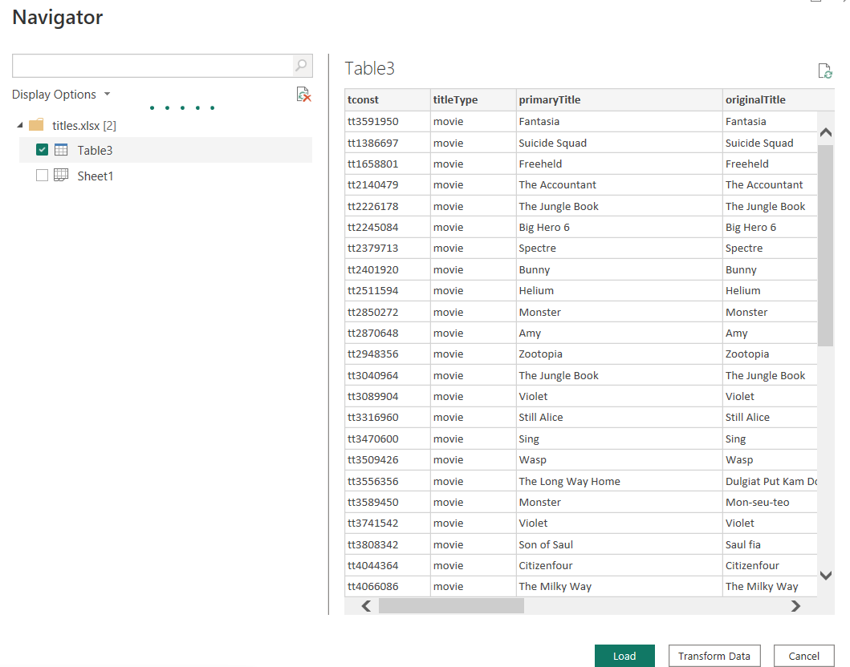

Transform Data

It will open the power query Editor. Here we can perform clean up(remove column, remove rows based on the Condition, Duplicate the model(dataset)

To Remove the titleType column

🡺 select titletype column

🡺Right Click

🡺Remove column

Remove Original Title column

Rename PrimaryTitle to Movie Title

Filter Rows based on startYear 2014-2018

To do so we 2 option

🡺 Manual filter

🡺 Another one using Number Filter

🡺 Select the column🡺Right click🡺 Number Filter

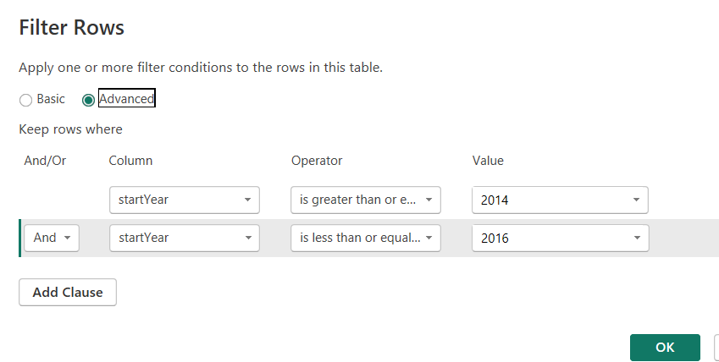

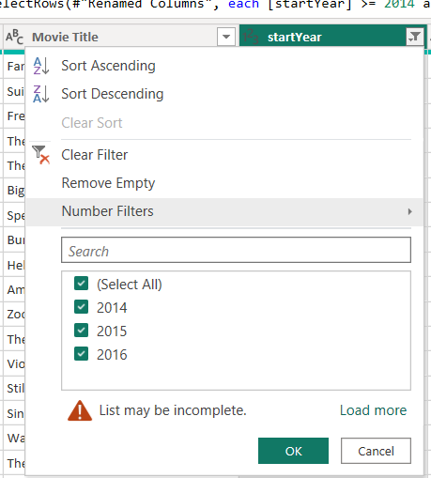

How to rename the Table3 to Movies



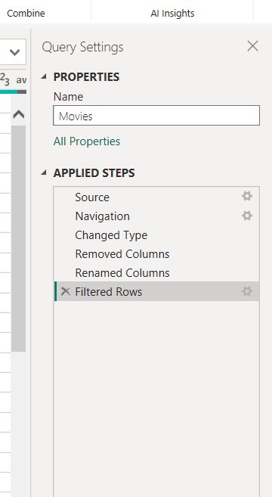

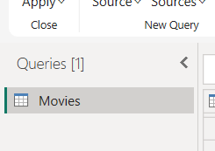

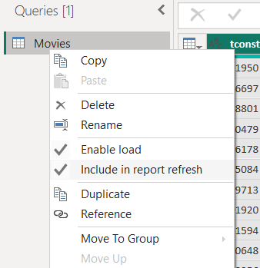

Choose the Duplicate

After that rename the Duplucated query to Genres



Now Genres should have only movieId (tconso) Genres.

So Remove all other columns in the Genres query

Select column 🡺 right click🡺 Split column🡺 By Delimeter🡺

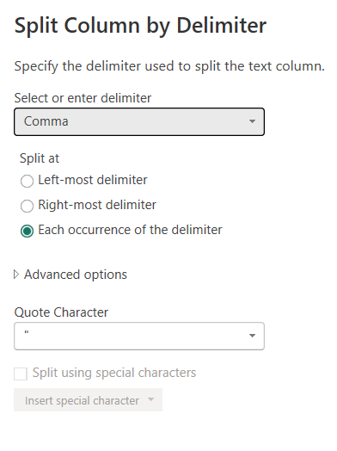

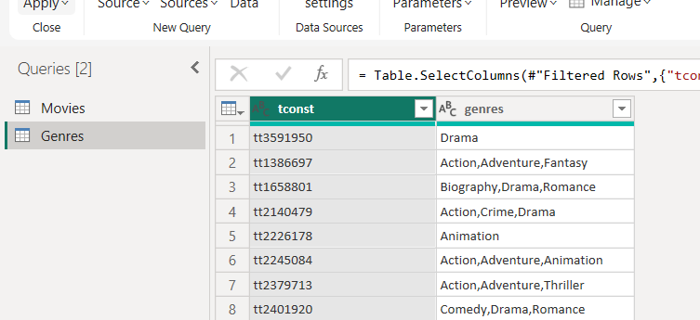

Ok

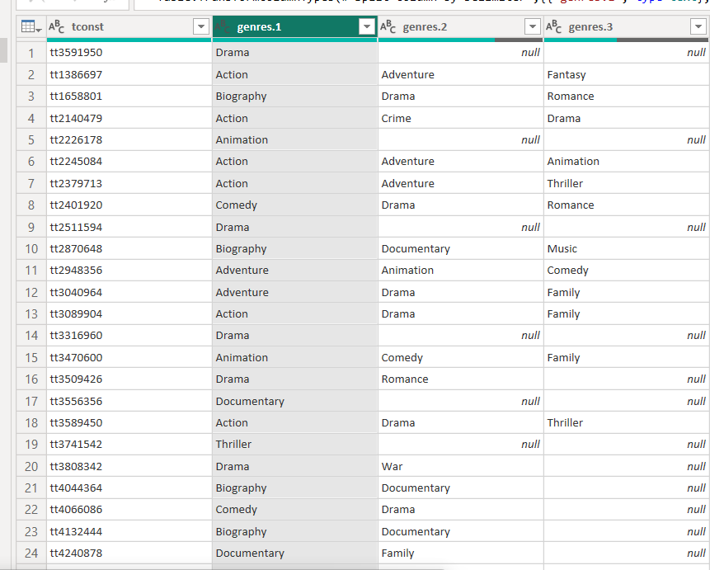

You are going split the genre into multiple columns.

Unpivot the columns🡺 Sleect all three grnres columns 🡺 Unpivot Selected column

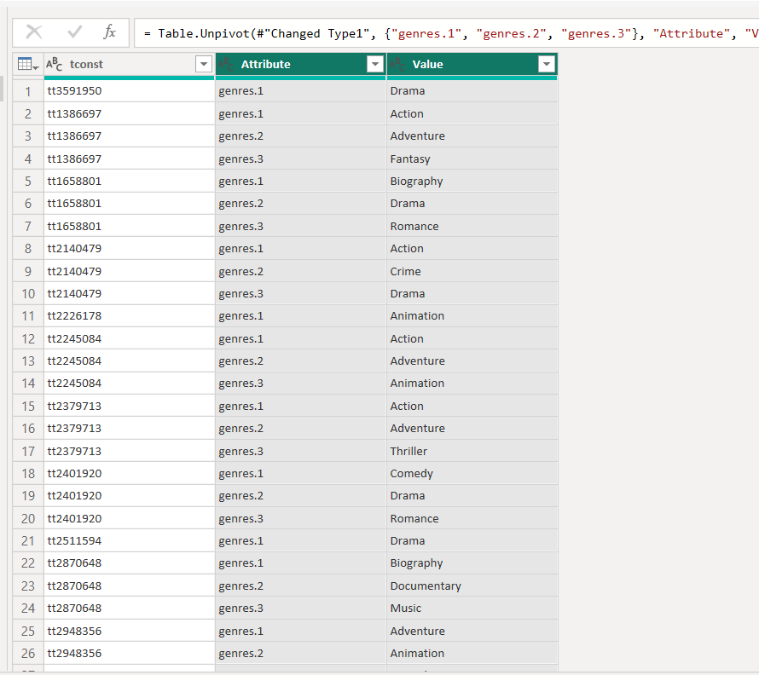

File🡺 Close And Apply the changes and save with extension Demo1.pbix